
July 2022
The Monthly AGC ‘Dirt’ Chapter E, Concord

www.actongardenclub.org

July 12th Road trip to Amherst

The drive each way will take about 1 hour 40 minutes. Yes, it is far but it is fabulous!
We will be making the field trip to Smith College Systematic Garden and Rock Gardens Botanical Gardens in Northampton, MA. Beginning at 10:30 AM a guide will give us a tour of the gardens and then we’ll go for lunch at a local restaurant.
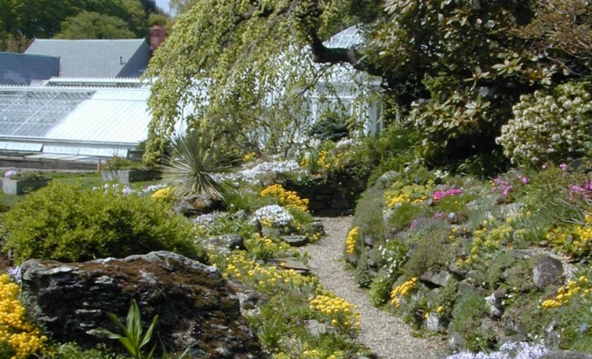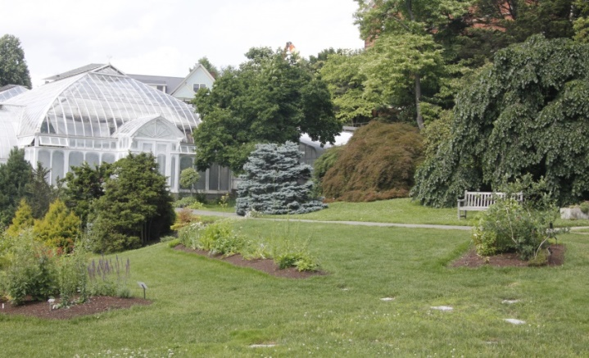
Smith College Rock Gardens Smith College Systematic Garden

Meet at the Acton Center Fire Station to carpool. We will depart from the fire station at 8:30 AM. Please arrive for an on time departure!
If you plan to join us, please let Jodi know (jodihomemaker@yahoo.com) so she can give a headcount to Smith and so we can figure out our carpool plan. It is ok if you are not sure.
If you plan to come, will you drive? If so, how many can your car fit?

Please wear comfortable shoes and bring water and a snack.

Membership:

We are pleased to introduce 2 new members to the Acton Garden Club.

Rachel Krebs is interested in photography and would like to know more about the Horticulture Study Group and Floral Design Study. Perhaps she can combine all these interests.

Ardythe Ashley is a published novelist who has worked as a volunteer in Monet’s Garden in Giverny, the NY Botanical Gardens, and the Acton Arboretum. She would like to volunteer at the Wildflower Garden
Please place their info on page 86 of your current yearbook.

Rachel Krebs Ardythe Ashley
248 Main Street, #4 84A Piper Rd
Acton Acton
(c) 857-231-6319 (c)646-286-9850
Rachelkb123@gmail.com ardytheashleysmall@gmail.com

Annual Student Scholarship
The Acton Garden Club annually awards a $2000 scholarship to a public high school student who resides in Acton. The candidate must display academic excellence and intend to pursue a career in Environmental related studies, i.e., Conservation, Agriculture, Horticulture, Climate Control, Forestry, Clean Water, or other related disciplines.
The recipient for this year’s scholarship is Hayden Jelinsky from Minuteman Regional High School. Hayden has been enrolled in the Horticulture and Plant Science program at Minuteman High and has taken on many leadership roles within the program. They are a member of the Future Farmers of America, serving as President of the group the last two years. Hayden devised a pest management program for the school greenhouse, as well as setting up beehives on the campus. They took a leadership role in integrating other students into these activities, as well as enthusiastically giving tours to members of the local community. The committee was very impressed with all that Hayden has done and felt that they will be a positive contributor to the horticultural field in the future.

Ann Leary Elementary Education Scholarship
The Board voted to give a one-time $1400 scholarship in memory of Ann Leary with money donated to the Club in her name. Ann was not only an active and longtime member of the Acton Garden Club but also spent her whole career as an elementary school teacher in Acton first at the Merriam School and retiring from McCarthy Towne.
The scholarship committee felt that Ann would be pleased at the selection of Grace Cookery as the recipient of this particular scholarship not only because she plans to major in elementary/special education but because of her extracurricular interests. While at AB, Grace has been a member of AB Buddies giving her experience working with special needs students. Grace was also a member of AB Ambassadors which shows willingness to work with and mentor younger students. The committee felt these are indicators of success for someone who wishes to work with young special needs students.

Floral Arrangements at the Acton Memorial Library Circulation Desk



Lora Maloney’s wonderful Don’t you love Sue Bricker’s use of use of colors and shapes. the Mason Jar?

Photos taken during the Hort Study Group’s field to Joe Pyeweed Garden

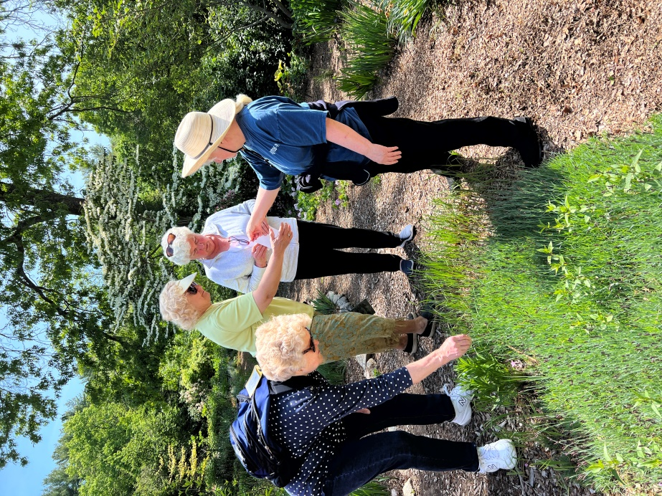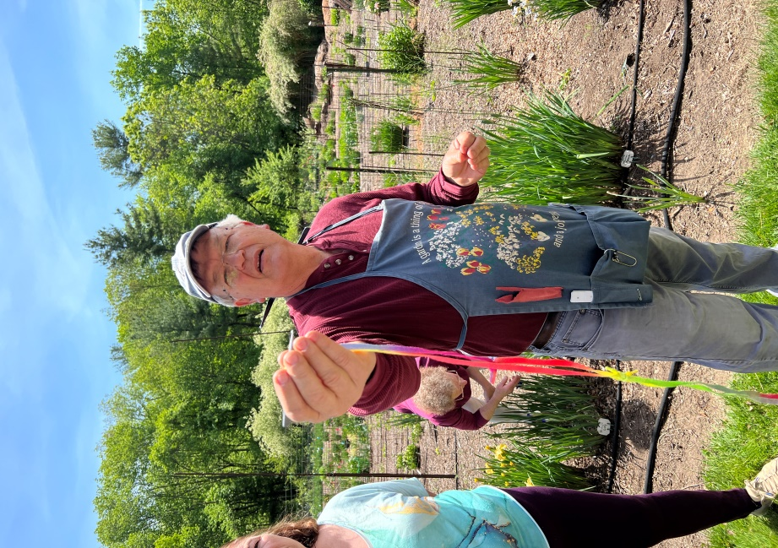
Enquiring minds want to know. Marty Schafer shows how you hand
pollinate an iris in order to get a new hybrid.

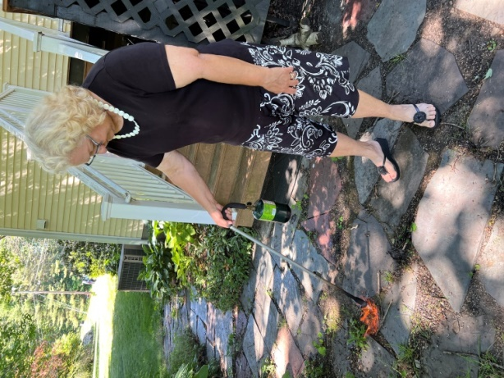

At the resent Horticulture Study Group meeting Susanne Fuller demonstrates her favorite garden tool to crisp weeds.

Daffodil bulbs for sale!
For many years, the garden club has offered daffodils for sale to our members and the community. This is a community service, not a fund raiser; we offer the bulbs at only a few cents more than cost.

Below are the two varieties that we are offering this year. If you want to order, please complete the attached form and return it to Susanne Fuller (5 Robert Rd., Acton) with your check payable to the Acton Garden Club by July 10th. On the FOR line on your check please write DAFFODILS.

If you have purchased the bulbs through the club in the past, you know that these are very high quality bulbs, and you also have a nice assortment of daffodils. If you have not purchased the bulbs in the past, it is time to start creating a beautiful spring garden.

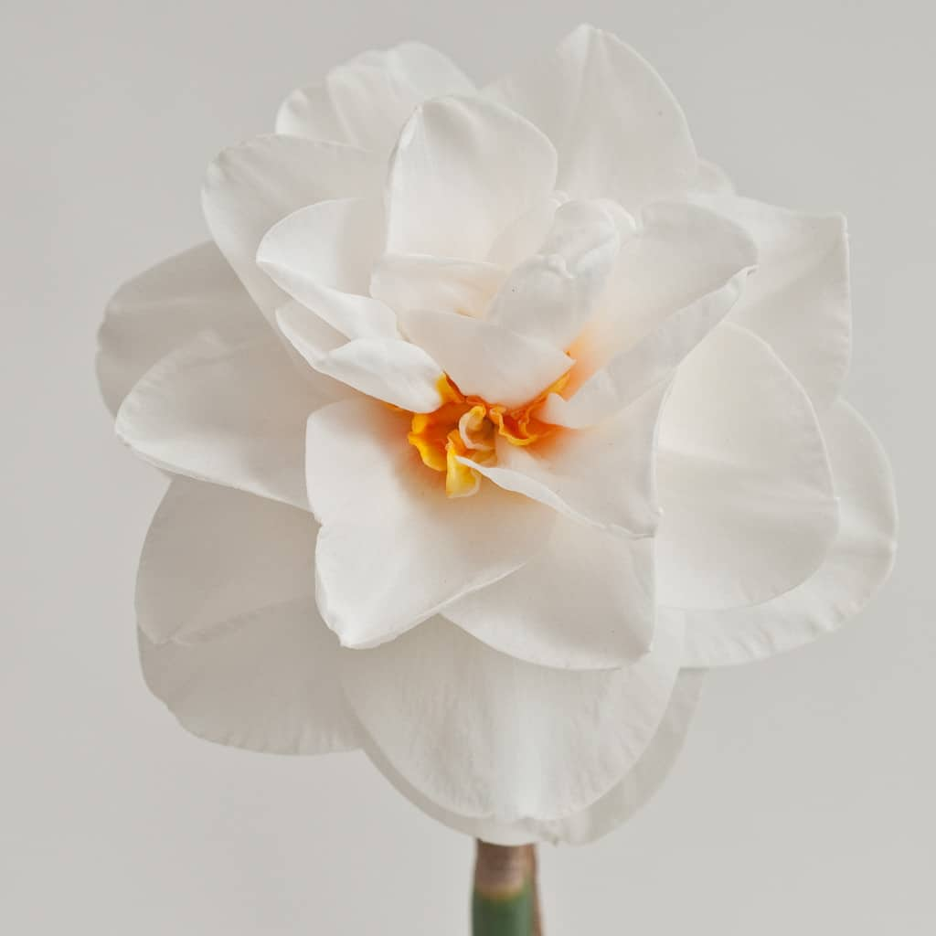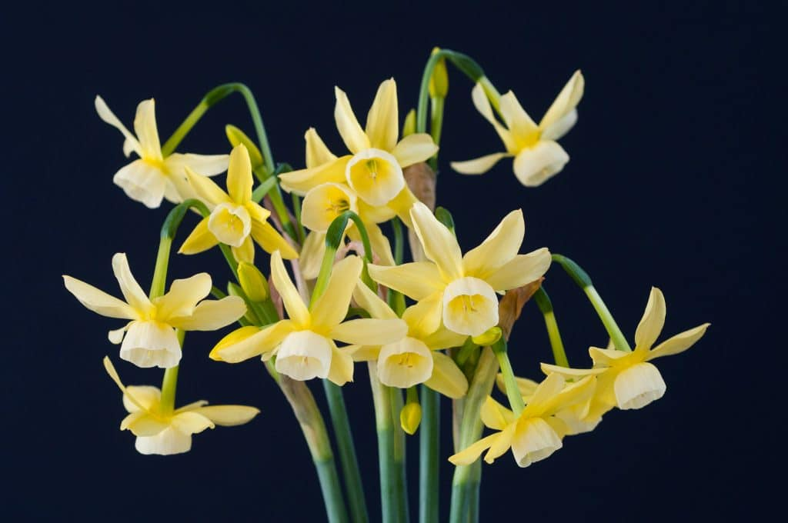
Acropolis Bloom Time Mid Hawera Bloom Time Mid

height: 16” – 18” height 8” – 10”

Glistening white flowers with orange-red A small primrose yellow daffodil that makes up for its
segments in the center. They are carried size by producing 6–8 flowers on each stem. Use it
well above the foliage for easy viewing. along a path, at the front of a border, near an
Lovely in the garden and terrific in a vase, entrance. Planted in a sunny spot, it can flower
which also allows ready access to their abundantly for many years. Hawera is a very good
spicy scent. neighbor. It mixes well with wild tulips such as Bakeri Lilac Wonder and with Grape Hyacinths

Washington Post 6/6/22

What science tells us about the mood-boosting effects of indoor plants
Decades of research have shown that houseplants reduce stress and recharge us. If you’re stuck in a small space for hours at a time, plants can bring about feelings of escape.
Just think what working in your garden will do for you!

Please take photos of your plants as they come into bloom from now into the fall. Send them along with your flowerless plants you deliver to the Red House next May for the ’23 Plant Sale. They will add inspiration for the new gardener who can’t imagine what that green leafy plant will look like when in full bloom. As they say, “A picture is worth a thousand words.”

Friday, June 20th Setting Up for the Annual Plant Sale

