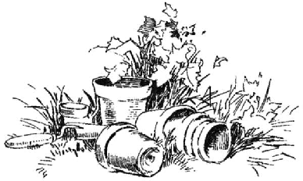
September 2020
The Monthly AGC ‘Dirt’ Chapter E, Concord

www.actongardenclub.org

What is coming up for the Club? (Refer to your yearbook for more details.)

All monthly meeting for the time being will be conducted virtual via Zoom.

- September 15th The virtual Monthly Business Meeting will start at 9:30 AM followed by the virtual program at 10:15 AM, Saving Summer presented by C.L. Fornari. The host of WXTK’s GardenLine will tell us how to keep tender perennials, tropical & annuals over winter. C. L. is a creative gardening expert who transitioned from artist to garden communicator in 1995. In addition to speaking, radio and writing, she blogs and runs a consultation service for Hyannis Country Gardens, an independent garden center on the Cape.
If you know anyone who is interested in joining one of our monthly meetings, leave a message for our webmaster on the club’s website at www.actongardenclub.org. and they will be contacted by an AGC member and given the information needed to log into the meeting.
Fran Portante has sent out the Zoom invite address & password for the September 15th meeting. The meeting will be in two parts. At the end of the business meeting you will log off and sign onto the program presentation.
The following is the link to Part 1, the Business Meeting:
https://us02web.zoom.us/j/81378724275?pwd=bWpUMXRqQmZuSElUREdzS3FOUjUrZz09
[Meeting ID: 813 7872 4275 Passcode: 739789 ]

Part 2 is the Program, Saving Summer. Per Karin's instructions, the link below will take you to a registration form. You must register for the Webinar. When you return the registration, you will be sent the link to the Webinar.

The experience of utilizing Zoom is new to many of us, but soon it will become as familiar as riding a bike!

- September 22 Horticulture Study Group will convene at 9 AM. Melissa Coucke will give a presentation on Orchids. Susanne Fuller will send out to Hort members the link to the virtual Zoom meeting & Password.

- September 29th Board Meeting @ 9 AM


Save the Date!
Floral Design Study Group
“Design Your Heart Out”—Autumn Harvest
October 20, 2020
9:00 AM on ZOOM!
Details for registration coming in the October DIRT.

